Document Information

Program id | ZMMRG0001
Development Class
Program Name | Goods Receipt Listing With Vendor Name
Current Version | 1.0
Last Updated (Functional)
Last Updated (Technical) | 06.May.2004 |  | By | Sudhindra. C
Date Created
Functional Spec (Approved) | <Date> | By |  | <Name>
 | <Date> | By |  | <Name>
Coding (Approved) | <Date> | By |  | <Name>
Quality Assurance on code | <Date> | By |  | <Name>
Program (Accepted) | <Date> | By |  | <Name>
Remarks

Revision History

Revision | Version date | Revised by | Change Description
1.0 | 14-Apr-2004 | New | Technical Specification Updated
Table of contents

1 Functional description 5
1.1 Background 5
1.2 Program Function Error! Bookmark not defined.
2 Authorisation Assignment 5
3 Transaction Code 5
4 Functional description 5
4.1 Program Flow Logic 5
4.2 Screen Layout 6
4.3 Input Data Definition Error! Bookmark not defined.
4.4 Requirement of Output Results 7
4.5 Program runtime environment 8
4.6 Sorting Rule 8
5 Limitations / Assumptions / Comments 9
6 Test Cases 10
6.1 Test case Summary 10
6.2 Testing Result and Analysis 10
6.3 Test Result Summary 11
6.4 Discrepancy Log (optional) 11
7 Technical Specification 13
7.1 Tables and Data sources used 13
7.2 Technical Program Flow Logic 14
8 Attachments and Samples 16

Functional and Technical Specification
Program Description
Company Name | Unisoft Infotech
Application Type | MM
Development ID | ZMMRG0001
Program Name | ZMMRG0001
Program Title | Goods Receipt Listing With Vendor Name
Program Type | Report
Running Mode | Online
Frequnecy | Periodic

Functional description

Background

Goods Receipt Listing With Vendor Name

Authorisation Assignment
This program will be executed by the MM user. This authorized user should be able to execute the program and process the error log. The authorization check is done by company code.

Transaction Code
<Will be decided later. Need to create a report tree>

Functional description

Report Selection Fields
.

No. | Field Text on Screen | Parameters/Select option | Data Type  & Length | Default Value | Required/Optional | Checking Rule
1 | Plant | P |  | P001 | Required
2 | Document Date | S |  |  | Optional
3 | Posting Date | S |  |  | Optional
4 | Movement Type | S |  | 101 to 102 | Required
5 | Vendor | S |  |  | Optional
6 | Material Doc. | S |  |  | Optional

Screen Layout

Report Selection Screen:

Requirement of Output Results

No. | Field Text | Data Type & Length | Sorting Keys | Form Feed Control Fields | Total / Subtotal Control Fields | Remark
 | mat. doc 10 | CHAR (10)
 | doc date 8 | DATS (8)
 | posting date 8 | DATS (8)
 | mat. description | CHAR (40)
 | user name 12 | CHAR (12)
 | DO No | CHAR (16)
 | quantity 13 | QUAN (13)
 | Unit of entry | UNIT (3)
 | PO nos | CHAR (10)
 | Item | NUMC (5)

Program runtime environment

Sorting Rule

Limitations / Assumptions / Comments

Prerequest:

Order Type should have Status Change Document.

Test Cases

Test case Summary

Test Case ID:TST_IPPEE_01 |  | Test Case Name: Final Breakpoint
Test Case Objectives: | - To test Enhancement/Report functionality as specfied in the Specs.  - To test and measure the performance of the Enhancement/Report  - To test the successful detection of various error condition  - To test the successful completion of re-processing routine
Description:
Requirements Addressed: | This test case addresses the Enhancement requirement IPPEE_01.
Success/Fail Criteria: | - Success criteria  - Performance Timing within stipulated requirements of 20 mins  - Accuracy of Final breakpoint updating of 100%  - Completeness of Error Handling  - Closed loop support, maintenance and re-processing process

Testing Result and Analysis

The following tables capture the test conditions, test steps and test results. Test condition, Test steps shall be updated prior to conduct of user acceptance testing.
Please make sure to test performance of this program as one of the testing conditions.

Testing Environment: Following test is conducted on (QA/DEV)

Test Conditions: 1 |  | Descriptions: Test program performance
Test Steps | Tester Action |  |  | Testing Data | Status (tester)
Actual Results (tester):

Test Result Summary

Instructions to tester: Record whether this test case passed or failed. Summarize the actual results relative to the expected results.

Test Run Results Summary
Pass/Fail Status | Summary of Actual and Expected Test Results | Additional Comments (Optional)

Discrepancy Log (optional)

Instructions to tester: Log discrepancies between expected and actual test results. For discrepancies that warrant initiating a Problem Report, record a brief statement of the problem under “Disposition”, and enter the problem report in the Project’s problem tracking system.

Discrepancy Log
Problem ID | Description | Disposition
0001
0002
0003
0004
0005
0006
0007
0008

Technical Specification

Selection Screen Fields used

Screen Field | Type | Obligatory | Default Value | Description
P_BUKRS | Parameter | Y |  | Company Code
S_WERKS | Selection | Y |  | Plant
P_MJAHR | Parameter | Y |  | Year
P_FPERIO | Parameter | Y | ‘X’ | From Period
P_TPERIO | Parameter | Y | ‘X’ | To Period
S_MTART | Selection |  | ‘X’ | Material Type

Tables and Data sources used

Tables used | Attribute | Description
MSEG |  | Document Segment: Material
MKPF |  | Header: Material Document
MAKT |  | Material Descriptions
LFA1 |  | Vendor Master (General Section)
EKPO |  | Purchasing Document Item

Tables fields

Fields used | Table | Description
MBLNR | MKPF | Number of Material Document
BUDAT | MKPF | Posting Date in the Document
MATNR | MSEG | Material Number
MAKTX | MAKT | Material Description
USNAM | MKPF | User name
LIFNR | MSEG | Account Number of the Vendor
ERFMG | MSEG | Quantity in unit of entry
MEINS | MSEG | Base Unit of Measure
ERFME | MSEG | Unit of entry
EBELN | MSEG | Purchase order number
EBELP | MSEG | Item Number of Purchasing Document
NAME1 | LFA1 | Name 1

Input Screen Fields

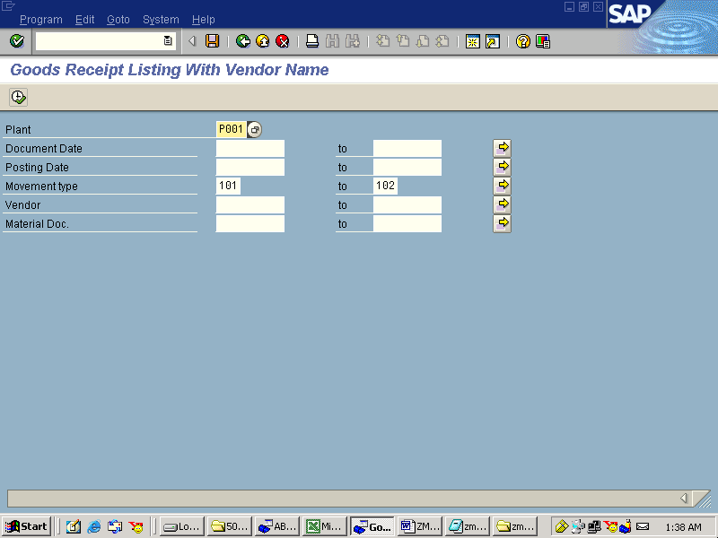

Output Results :

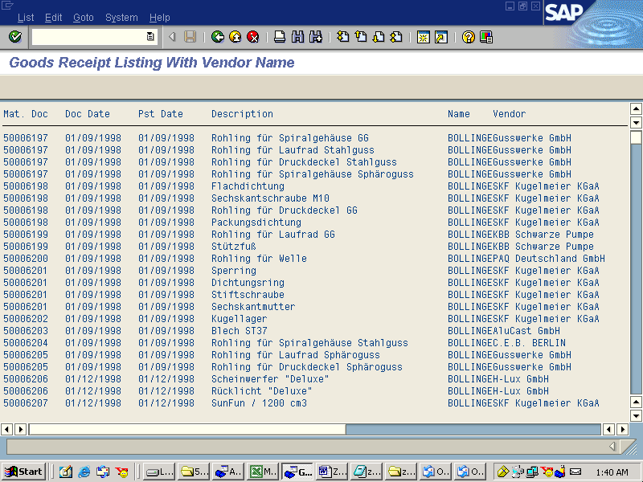

Technical Program Flow Logic

Attachments and Samples

